Greater Dandenong Division Winter sport competition-2018

Date –Friday 27 July 2018.
Venue – Greaves Reserve, Bennet St, Dandenong Melways 90 A7

Sports fixture and match time –
All teams to arrive at 9.45a.m for briefing.

Match Teeball mixed
Final 10.00 a.m Dandenong District v Noble Park District I hour or 7 innings

Matches – Football - 2 x 20 minute halves with 5 minute interval
Round 1 10.00a.m. Dandenong District v Springvale District
Round 2 11.00a.m. Losing team of round 1 v Noble Park District
Round 3 12.00p.m. Noble Park District v winner of round 1

Matches – Soccer mixed and Soccer girls- 2 x 20 minute halves with 5 minute interval
Round 1 10.00a.m. Dandenong District v Springvale District
Round 2 11.000a.m. Losing team of round 1 v Noble Park District
Round 3 12.00p.m. Noble Park District v winner of round 1

Matches – Netball mixed and girls – 2 x 12 minute halves with 2 minute interval
Round 1 10.00a.m. Dandenong District v Springvale District
Round 2 11.00a.m. Losing team of round 1 v Noble Park District
Round 3 12.00p.m. Noble Park District v winner of round 1
Alternate mixed / girls per hour

Umpires / referees
Umpires and referees are provided.
Coaches of teams playing to act as timekeepers and or lines or boundary officials.

Division Winners
Winning District team determined by a team that -
- Wins both matches 2. Wins on percentages 3. Soccer – winner on penalties

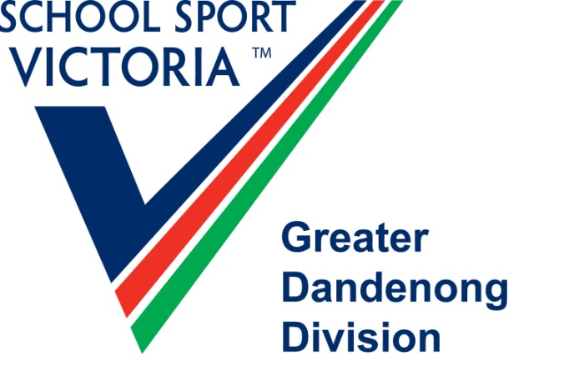
Donna Westie
SSV Greater Dandenong Division
donnawestie@outlook.com

0407 177 159

